**Project Design Phase-II**

**Technology Stack (Architecture & Stack)**

| Date | 10 November 2023 |
| --- | --- |
| Team ID | 591944 |
| Project Name | **Time Series Analysis For Bitcoin Price Prediction Using Prophet** |
| Maximum Marks | 4 Marks |

**Technical Architecture:**

The Deliverable shall include the architectural diagram as below and the information as per the table1 & table 2 **Example: Order processing during pandemics for offline mode**

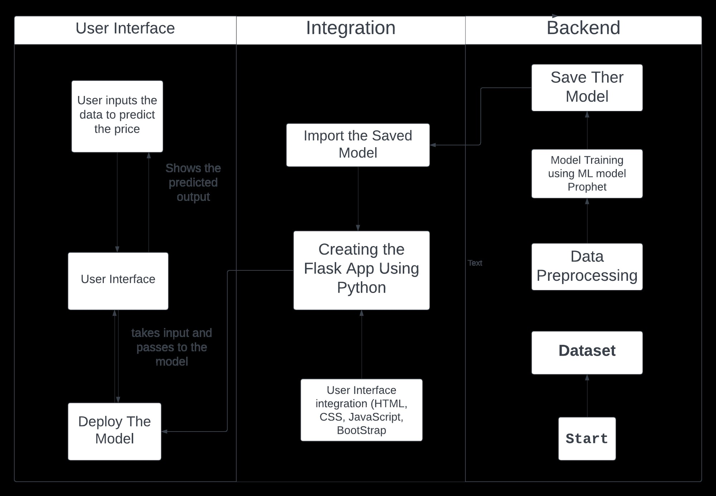

Guidelines:

1. Include all the processes (As an application logic / Technology Block)

2. Provide infrastructural demarcation (Local / Cloud)

3. Indicate external interfaces (third party API’s etc.)

4. Indicate Data Storage components / services

5. Indicate interface to machine learning models (if applicable)

**Table-1 : Components & Technologies:**

| **S.No** | **Component** | **Description** | **Technology** |
| --- | --- | --- | --- |
| 1. | User Interface | Web UI, Mobile App | HTML, CSS, JavaScript / Angular Js / React Js etc. |
| 2. | Time Series Analysis | Data preprocessing, model training, prediction | Python, FBProphet |
| 3. | External APIs | Yahoo Finance, Cryptocurrency market API | REST, JSON |
| 4. | Data Storage | Bitcoin price data | Local File Manager, Google Drive |
| 5. | Infrastructure (Server / Cloud) | Local Server deployment | Local Server |
| 6. | Machine Learning Model | Facebook Prophet for time series forecasting | Python, Prophet |

**Table-2: Application Characteristics:**

| **S.No** | **Characteristics** | **Description** | **Technology** |
| --- | --- | --- | --- |
| 1. | Open-Source Frameworks | Use of open source framework for model development | Prophet, Scikit-Learn |
| 2. | Security Implementations | Data encryption, secure API communication | HTTPS, API keys |
| 3. | Scalable Architecture | Local scalability through containerization | Local File Manager |

| 4. | Availability | Local Availability on dedicated servers | Local Servers |
| --- | --- | --- | --- |
| 5. | Performance | Optimization for high request rates, caching strategies | In-memory caching |